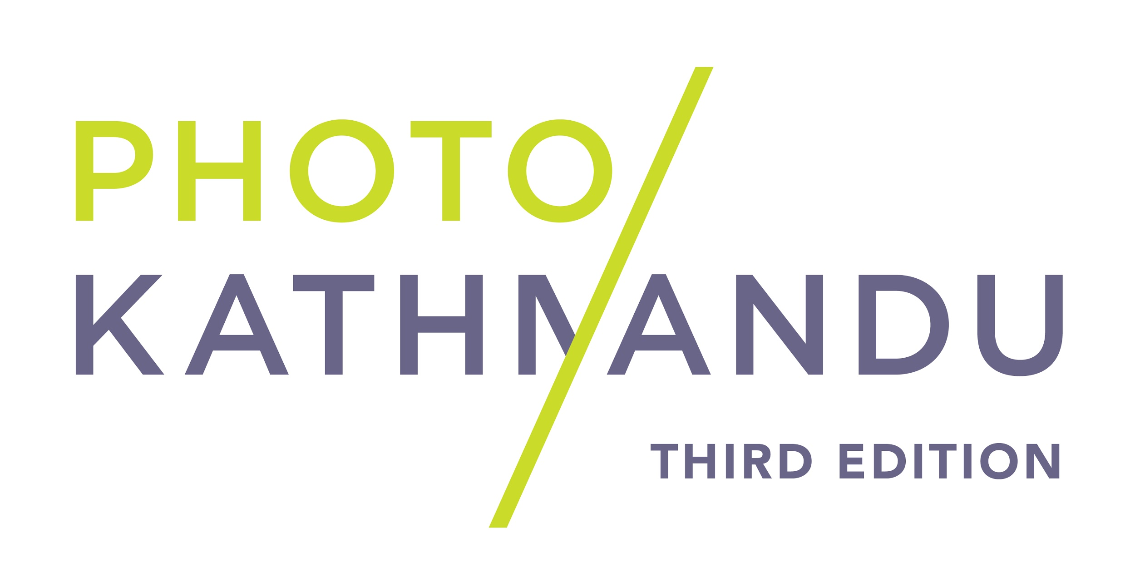
PRESS RELEASE 2
8 October 2018

PHOTO KATHMANDU 2018
12 OCT – 16 NOV 2018

photo.circle and its partners are proud to announce the programming for the third edition of Photo Kathmandu, to be held between 12 October and 16 November 2018. The festival puts the spotlight on gender, power, identity, patriarchy, and sexuality this year, and all public programming explores these themes.

Photo Kathmandu 2018 will be inaugurated by Hon. Tham Maya Thapa, Minister of Women, Children and Senior Citizen on 12 October 2018. The festival is hosting 14 print exhibitions, 4 slideshow nights, 17 artist talks and panel discussions, 8 workshops, a mixed-media residency, as well as the festival’s first edition of South Asia Incubator program. Over 60 photographers, curators, editors, writers and art practitioners from over 20 countries are participating in the festival, and an estimated half a million locals and tourists are expected to visit the festival.

The print exhibitions feature works from a diverse roster of Nepali and international artists who will present their work in two phases. The first phase begins on October 12, and features The Lightning Testimonies by Amar Kanwar; The Public Life of Women: A Feminist Memory Project co-curated by Diwas Raja Kc and NayanTara Gurung Kakshapati; Confrontations by Bunu Dhungana, Islands of Our Bodies by Keepa Maskey, Irina Giri, and Sonam Choekyi Lama; There are no Homosexuals in Iran by Laurence Rasti; The Independent Chronicler by Shreedhar Lal Manandhar; Something Big and Glorious and Magnificently Insane: Hippie Kathmandu co-curated by Lucia De Vries and Prasiit Sthapit. 7 more exhibitions will go up on October 26 for the second phase including Sempah Tsere, Kipu Sho by the Langtang Memory Project; The Lost Head and the Bird by Sohrab Hura; Where Love is Illegal by Robin Hammond; BINDBox # 3 by the BIND Collective; Whose and Whom: The Body as a Political Landscape curated by Anshika Varma, Brotherhood | Gurkhas’ Sons by Nina Manandhar and an Open Archive allowing access to the collections of Nepal Picture Library and Madan Puraskar Pustakalaya. All exhibits will remain up until Nov 16th except The Lightning Testimonies by Amar Kanwar, which will remain up for 6 months.

Photo Kathmandu kickstarted by welcoming 6 artists from 5 different countries to its month long mixed media residency program. Working with guest curators Veeranganakumari Solanki and Sujan Chitrakar while living together in Patan, these artists have been exploring intersections between photography and various other mediums to create work that will be presented in a public pop-up exhibition during the festival’s main programming week.

The festival will begin with an Opening Weekend of programming on 13th and 14th October which will feature talks and presentations by Amar Kanwar, Pema Abrahams, Agastaya Thapa, Jennifer Bradley, Diwas KC and Ilgın Deniz Akseloğlu. The main bulk of the programming will continue on October 26 until November 1. That week will feature more works in the form of curated slideshow projections; professional development opportunities for Nepali and international artists through workshops, portfolio reviews, and networking events; and public engagement during artist talks and panels.

Photo Kathmandu creates space for conversations between the city and its public, its pasts and its aspirations. As a festival it seeks to challenge the limits of ‘artistic intervention’ and create in-depth public engagement on socio-political topics of local relevance. The festival runs a dynamic Arts and Education program that is run by a group of committed young arts educators who invite Nepali students, teachers, professional networks, and families to engage with the festival through guided tours, a specially designed learning kit that helps viewers of all ages engage with the works being featured and a seminar for teachers.

About the organizers
photo.circle was established in 2007 as a platform for photography in Nepal. Through workshops, publications, exhibitions and commissioned assignment work, photo.circle strives to create opportunities for photographers to learn, exhibit, publish and market their work. It also runs the Nepal Picture Library, Nepal’s only digital photo archive that strives to document and inclusive visual history of Nepal.

For further enquiries, please contact:
Sushrut Acharya – press@photoktm.com

For regular updates
www.photoktm.com
www.facebook.com/photoktm
www.instagram.com/photoktm
www.twitter.com/photoktm
www.youtube.com/c/PhotoKathmanduNepal
#photoktm2018

