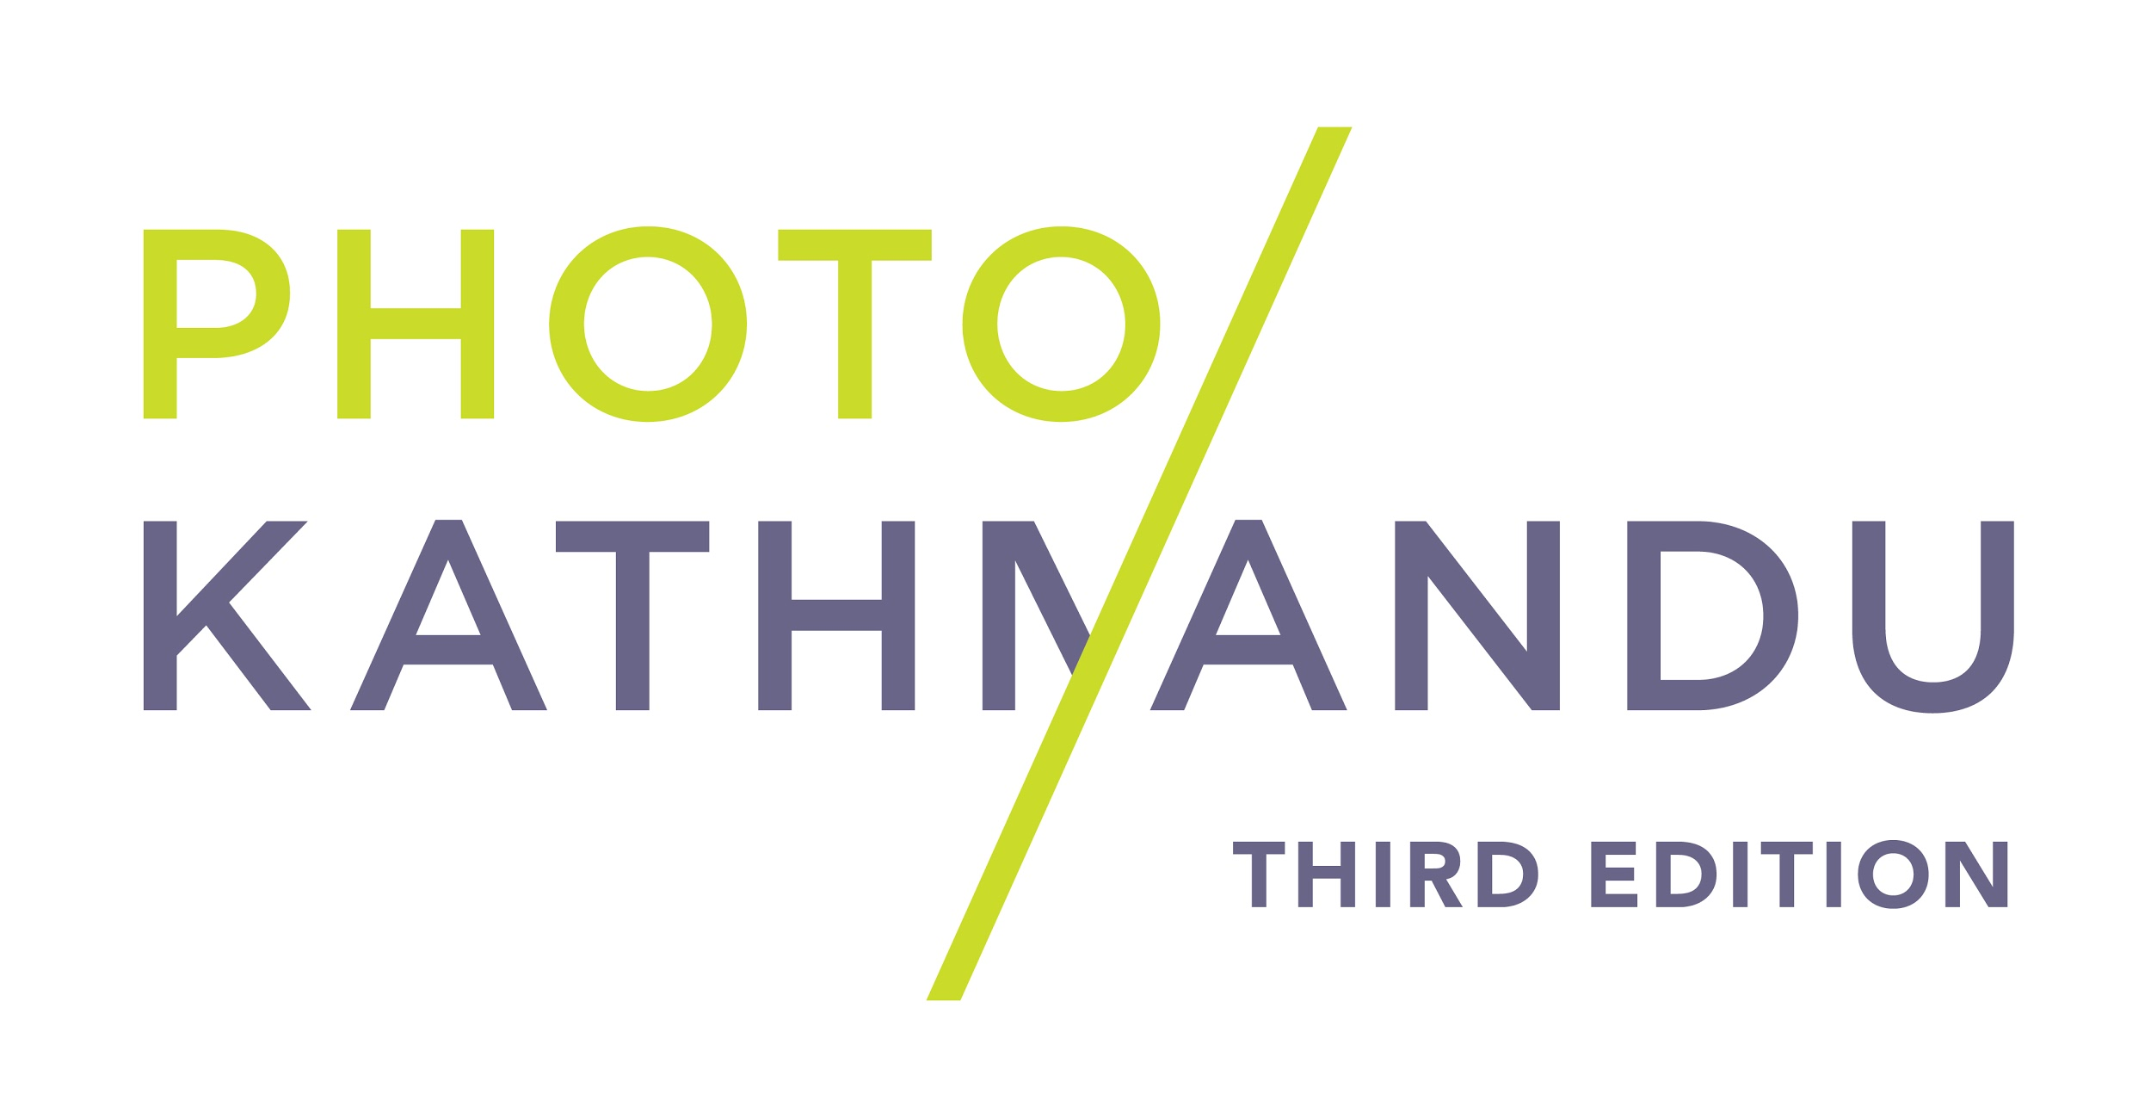
PRESS RELEASE 3
26 October 2018

PHOTO KATHMANDU 2018
12 OCT – 16 NOV 2018

**FOR IMMEDIATE RELEASE**

Dr. Shahidul Alam receives the Photo Kathmandu 2018 Award of Excellence

Photo Kathmandu is honored to present the Photo Kathmandu 2018 Award of Excellence to Dr. Shahidul Alam for his instrumental contributions towards the development of Nepali photography and journalism.

Dr. Shahidul Alam is a pioneering Bangladeshi photographer, writer, curator, educator and activist. He is the founder of Drik Picture Library, Pathshala South Asian Media Institute, Chobi Mela International Festival of Photography and Majority World, all groundbreaking Bangladeshi institutions.

Dr. Alam represents the highest values of truth, justice and social equality. For over two decades, individuals and institutions in the Nepali photography and journalism fraternity have had the privilege of working with him and learning from him. He has been a close colleague, mentor and friend to many in Nepal, enabling access to professional development opportunities, initiating international exchanges, and always speaking up for free speech. His visionary leadership has helped to shape the development of photography, media and cultural practices in Nepal, across South Asia and the rest of the world.

Dr. Alam was detained by the Detective Branch of the Bangladesh police on 5th August 2018 and has been charged under Section 57 of the Information Communication Technology (ICT) Act. The allegations were that, Dr. Shahidul Alam, through a Facebook live video, “disseminated false, confusing and provocative statements that caused a deterioration in the law and order situation of the state, hurt the image of the state and hurt the sentiment of young students that instigated them to create social instability and engage in destructive activities.”

Today, Dr. Shahidul Alam has been in jail for 82 days. His last bail petition was deferred again, and the next hearing has been scheduled for Sunday, 28TH October 2018.

The decision to confer this year’s Photo Kathmandu Award of Excellence to Dr. Shahidul Alam was unanimously reached by the Photo Kathmandu 2018 Awards Committee that included Bikas Rauniar (Senior Nepali photojournalist), Bikas Karki, (President of Photojournalists Club Nepal and Photo Editor of Annapurna Post) and Sagar Shrestha (President of National Forum of Photojournalists).

Photo Kathmandu is an international photography festival organized by photo.circle. The festival presents exhibitions, workshops, an artist residency and a diverse range of public programming to Kathmandu audiences and international visitors every two years. Through its core and collateral programming, Photo Kathmandu creates in-depth engagement with local audiences and special interest groups on themes and topics of socio-political relevance locally.

For further enquiries, please contact:
Sushrut Acharya – press@photoktm.com

For regular updates
www.photoktm.com
www.facebook.com/photoktm
www.instagram.com/photoktm
www.twitter.com/photoktm
www.youtube.com/c/PhotoKathmanduNepal
#photoktm2018

